|  |  |
| --- | --- |
| Scrappy's New Look Unveiled at Kennesaw State Flight Night - News ...  Project Management System User Manual | Jonathan gamble (Project lead)  rich cohen  renee davis townsend  tu bui    For Dr. Hassan Pournaghshband  SWE6633 - Summer 2020 (Group 2) |

*This page intentionally left blank*

Table of Contents

Common Items 3

Telerik Banner 3

How to use Grids 3

Overview 4

Workflow 5

Home Page 5

View Projects 5

Add a new project 6

Edit a project 7

General Information 8

Team Members 9

Risks 10

Requirements 11

Efforts (Monitoring and Tracking) 12

Analyze Project Status 16

View Project Details 17

Delete a Project 18

About Section 19

# Common Items

## Telerik Banner

Project Management System is currently in a Prototype phase. The prototype was developed using a trial version of Telerik UI which means from time to time a banner will appear on the screen notifying the user of that fact. If this banner affects the functionality of the system, please refresh the web page and the banner should go away.



## How to use Grids

Project Management System uses the Telerik Grids for inputting and viewing data. Things of note include:

* The Grid validates in input from the user meaning the user must input all required fields when adding or updating data.
* To add an item to a grid, choose the “Add” button associated with the grid.
  + A new line will appear in the grid which is used to input the appropriate information in the Grid.
* If available, the user can update an item in a grid by double clicking the cell they want to update.
  + The field in the cell will allow for editing and the user can tab through to continue editing the data in the Grid.
* The Delete Button in the row of the Grid can be used to remove the row from the Grid.
  + The user will be asked if they are certain before removing the item from the Grid.
* Adding/updating/removing the data in the Grid does not automatically sync back to the database. To save the changes, use the “Save changes” button associated with the Grid to update the database.
  + All un-synced changes to the Grid will be marked with a red indicator in the cell of the grid.
* The “Cancel changes” button can be used to negate the changes made locally by the user and set the Grid back the state that matches the database.

# Overview

Project Management System is designed to be a simple and effective solution for project management. The system provides the ability to track project team membership, project risks and risk status, project requirements (functional and non-functional) and project labor/efforts.  The prototype of the Project Management system as of July 15th 2020 is being hosted at <https://projmgmtsystem.azurewebsites.net/>.

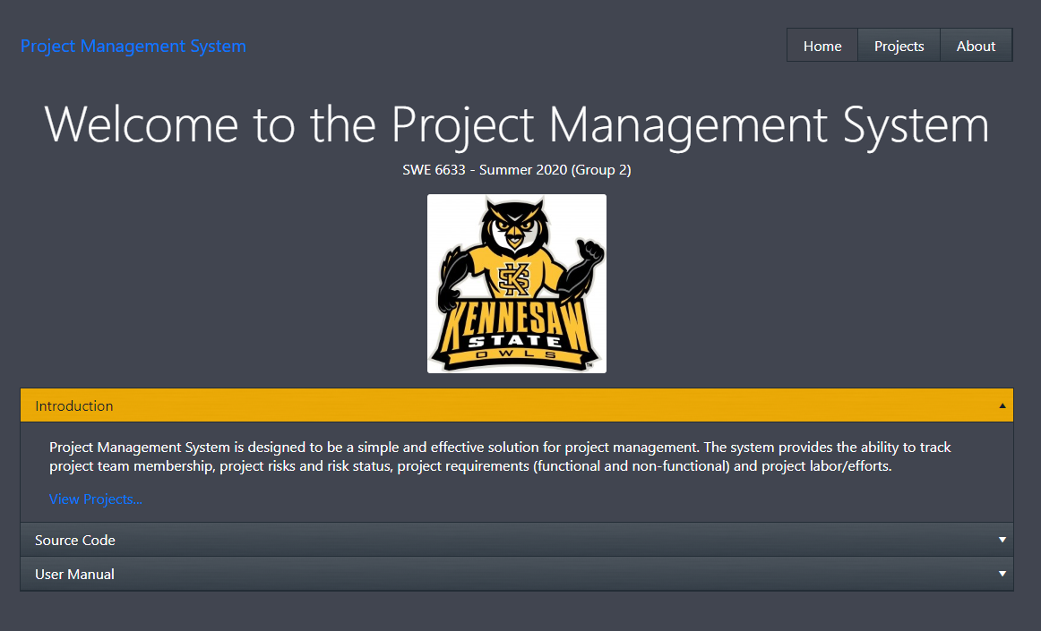

# Workflow

## Home Page

The home page of the Project Management System provides the user a quality welcome and introduction. The system provides information on the functionality of the website, information about the location of the source code and the location of this user manual.

## View Projects

From home page, there are a couple ways to view the projects currently in the system. The user can select the “Projects” tab at the top of the Page or use the convenient “View Projects…” link provided in the introduction section.

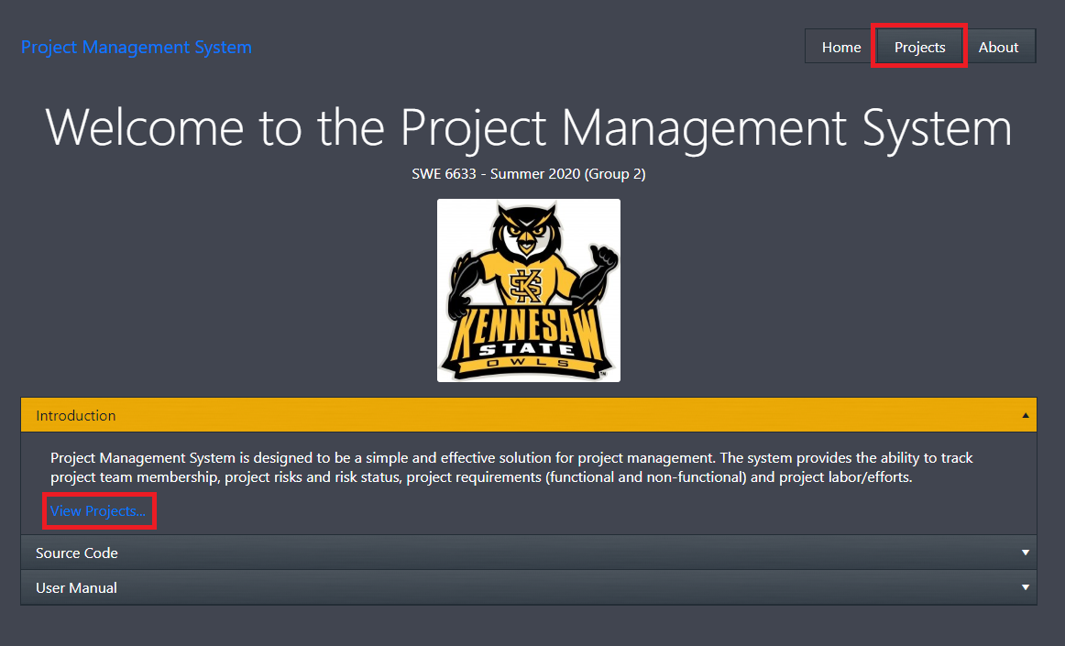

Once the user has arrived at the Projects page, they will be presented with the list of existing projects. For each project listed, there will be options to view the project details, edit the project or delete project. There will also be an option to add a new project to the list.

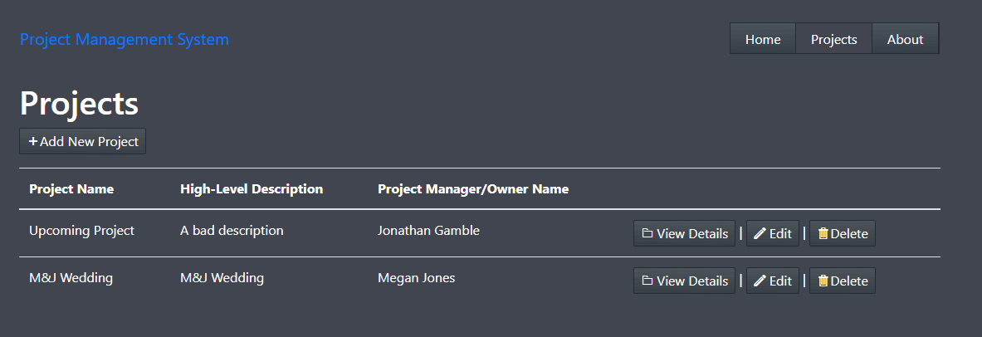

## Add a new project

To create a new project, the user can click the “Add New Project” button on the Projects page. The button will navigate the use to a new page that will require the following inputs from the user:

* Project Name
* Project Manager/Owner Name (must be a valid first and last name – middle name is optional)
* High-Level Description

Once the user has filled the fields with valid inputs, the page will allow the use to create the new project using the “Create Project” button. Once the project is created, the user will be navigated the Edit Page for the newly created project. The “Back to List” button will navigate the user back to the “Projects” page without creating the new project.

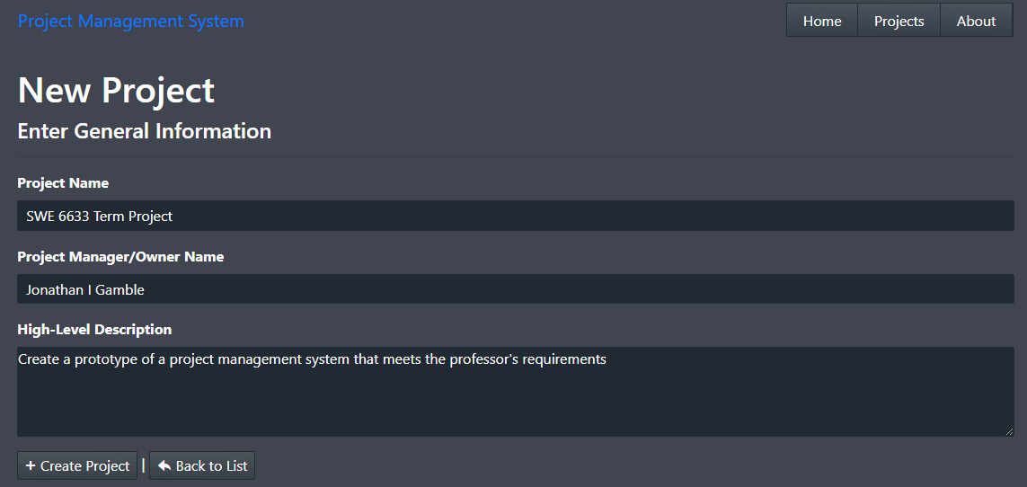

## Edit a project

When the user creates a new project or chooses the Edit option from the Projects page, they will be navigated to the Edit page. The Edit page allows the user to view and edit the following information related to the selected project:

* General Information
* Team Members
* Risks
* Requirements
* Efforts (Monitoring and Tracking section)

### General Information

This section allows the user to update the general information that describes the selected project. This section uses similar validation methods as the Create Project Page. Once all of the fields have been filled with valid inputs, the Update Project button will allow the user to sync the updated back to the database. The “Back to List” button will navigate the user back to the “Projects” page without syncing unsaved changes back to the database.

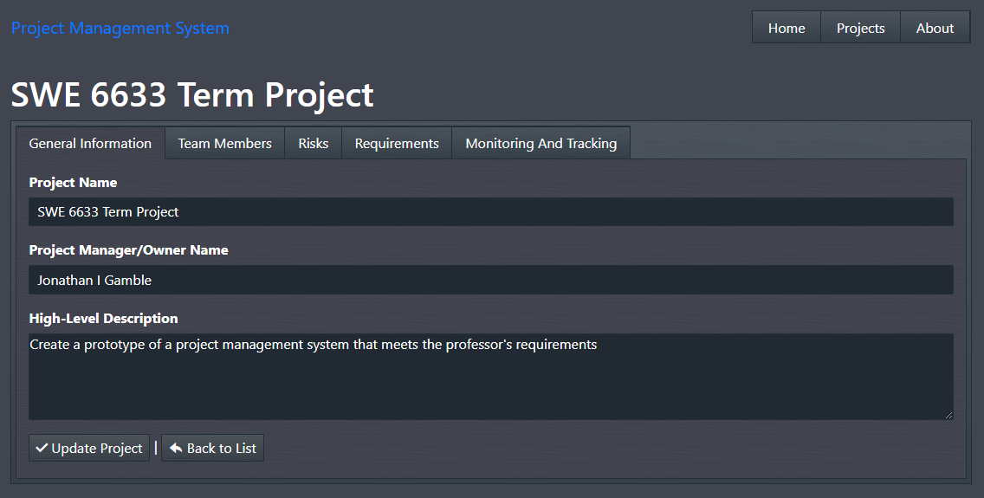

### Team Members

This section allows the user to add, edit or remove team members from the project. This list of team members will be used when inputting project efforts.

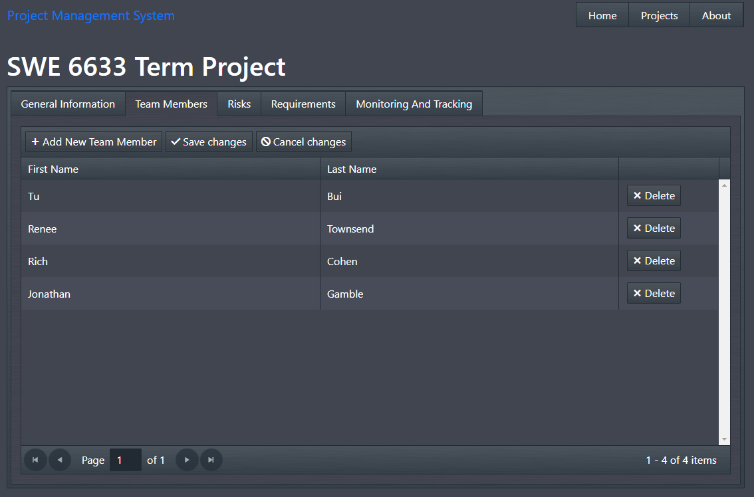

### Risks

This section allows the user to add, edit and delete risks associated with the project and their status.

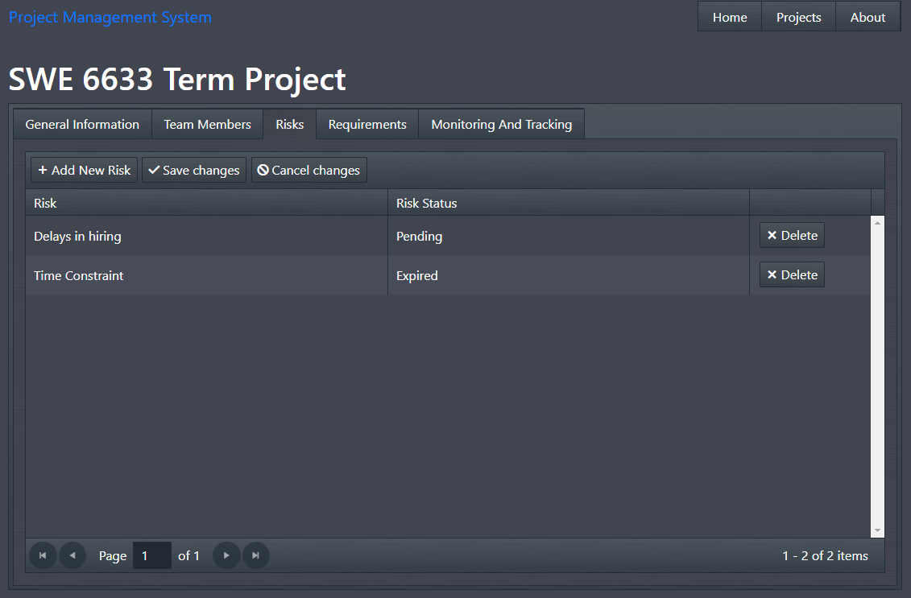

### Requirements

This section allows the user to add, edit and delete the requirements of the project. When inputting a requirement, the user will have two pre-defined options for the requirement type: functional and non-functional. This list of requirements will be used inputting project efforts.

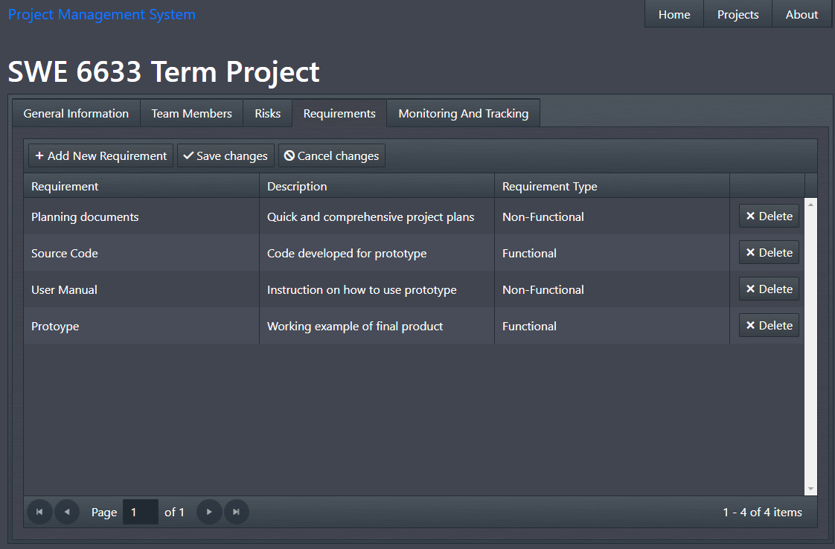

### Efforts (Monitoring and Tracking)

The Monitoring and Tracking section allows the user to input the efforts completed by the team members towards the project’s requirements. It will also provide an option to analyze the total expended hours for each requirement broken down by effort type.

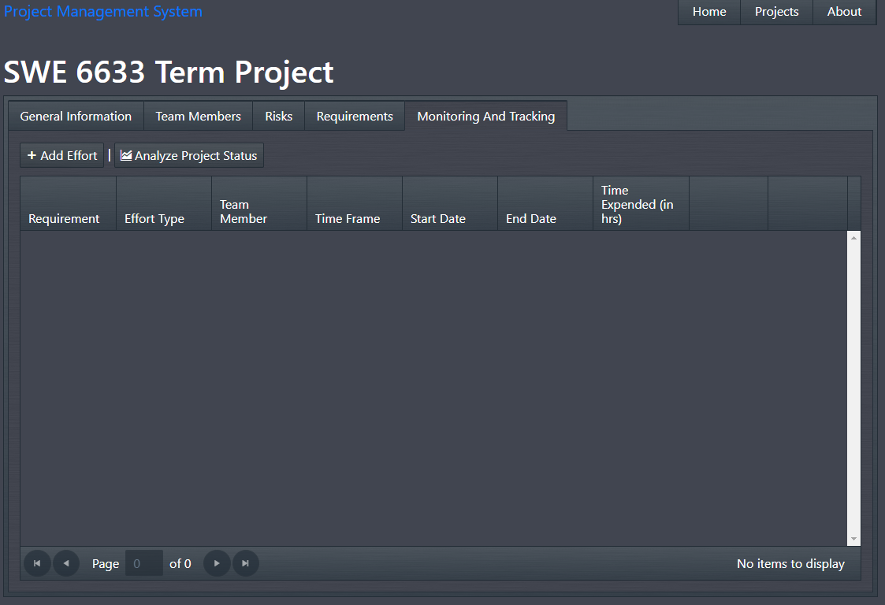

#### Add Effort

To add effort, the user will click the “Add Effort” button above the Grid. This will pop up a form that will require the following information:

* Requirement
  + The user will be able to choose one of the project requirements to associate the effort with.
* Requirement Effort Type
  + This is a pre-defined list of effort types to categorize the effort done for the requirements
  + Options include:
    - Requirements Analysis
    - Designing
    - Coding
    - Testing
    - Project Management
* Team Member
  + The user will be able to choose one of the project team members to associate the effort with.
* Time Frame
  + This is a pre-defined list of time frames (Daily or Weekly) to annotate the time frame the effort was competed in.
* Date From
  + This is the date of the effort was started.
  + The Date To value will be set based on the Date From and the selected Time Frame.
    - If the Time Frame is Daily, the Date To will be the same as Date From. Else, it will be seven days after the Date From.
* Time Expended (in hrs)
  + The total amount of hours spent on the effort during the Time Frame

Once all the fields have been filled with valid inputs, the Add Effort will allow the user to add the effort to the project. Then, the pop-up window will close and the Effort Grid will update to reflect the newly added data.

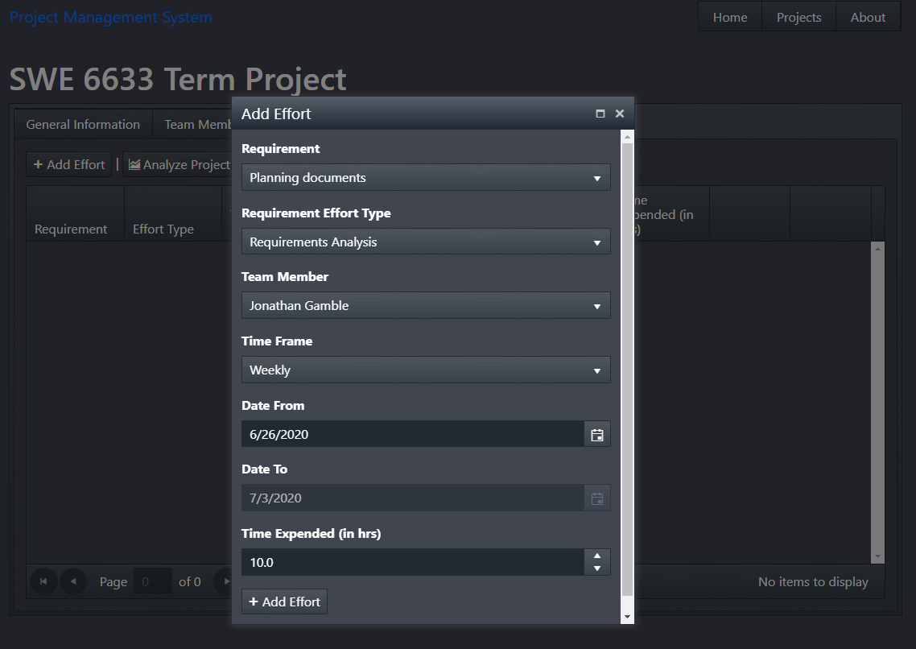

#### Edit Effort

Unlike the other grids, the effort grid does not allow for inline editing. To edit an effort, the user must choose the Edit option in the row on the Grid. A pop-up window will open that will allow the user to edit the selected effort. The validation will be similar to the “Add Effort” pop up. Once all the fields have been filled with valid inputs, the “Update Effort” button will allow the user to updated the selected effort. Then, the pop-up window will close and the Effort Grid will update to reflect the newly updated data.

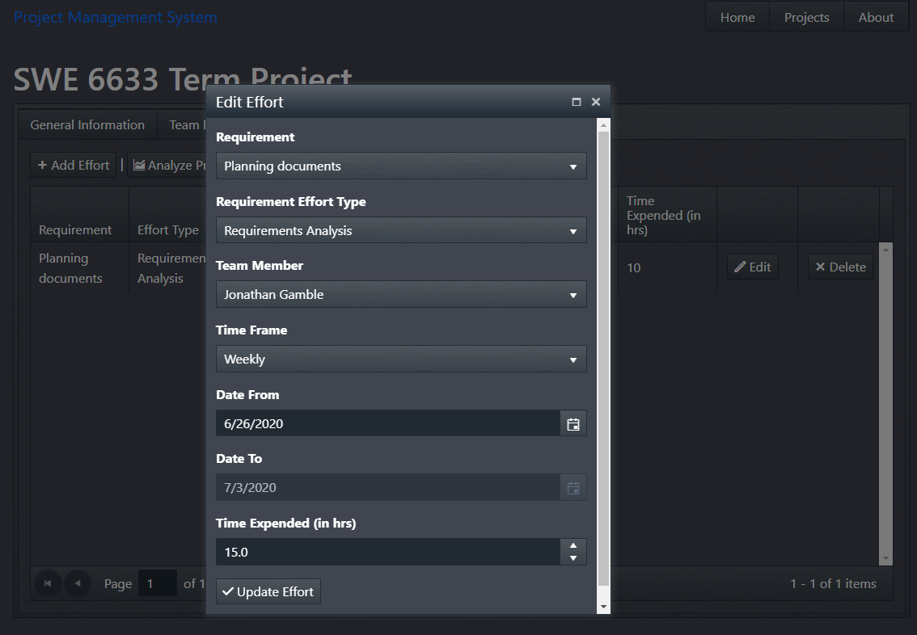

#### Delete Effort

To delete an effort from the project, the user must click the “Delete” button in the row on the Grid. The user will be prompted to make sure they are certain before deleting the effort. Note: Unlike the other grids, the effort grid does sync back to the database right away. As soon as the user confirms the deletion, the effort will be permanently deleted.

### Analyze Project Status

Additionally, in the Effort (Monitoring and Tracking) section, there will be a “Analyze Project Status” button above the Effort Grid. This button can be used to open a pop-up window with a detailed breakdown of the total expended hours by requirements analysis, designing, coding, testing, project management for each project requirement with effort.

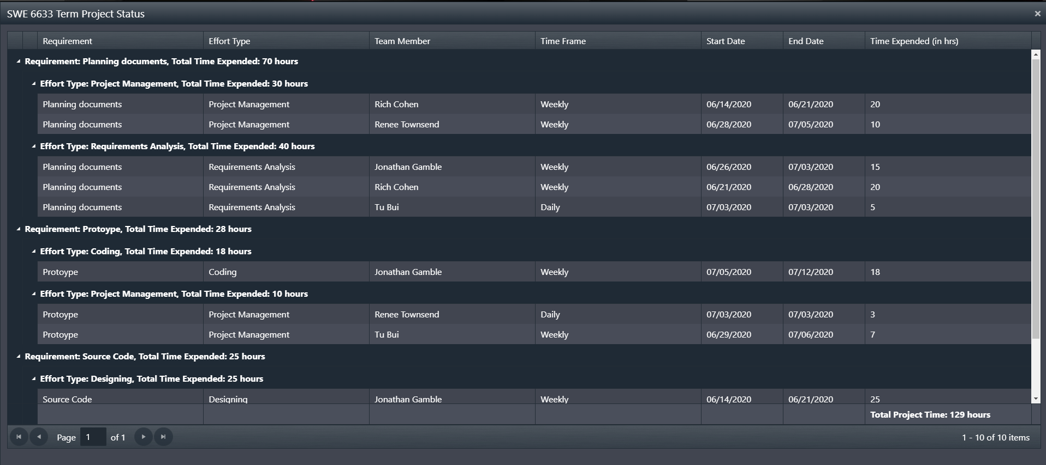

## View Project Details

To view the details of the project in a read-only method, the user can choose the View Details option on the Projects page. The Projects Details page will allow the user to view the project’s information and analyze the project’s status similar to the Edit form. The page will also provide the ability to navigate to the Edit page of the project via the “Edit” button or return the Projects page via the “Back to List” button in the General Information section.

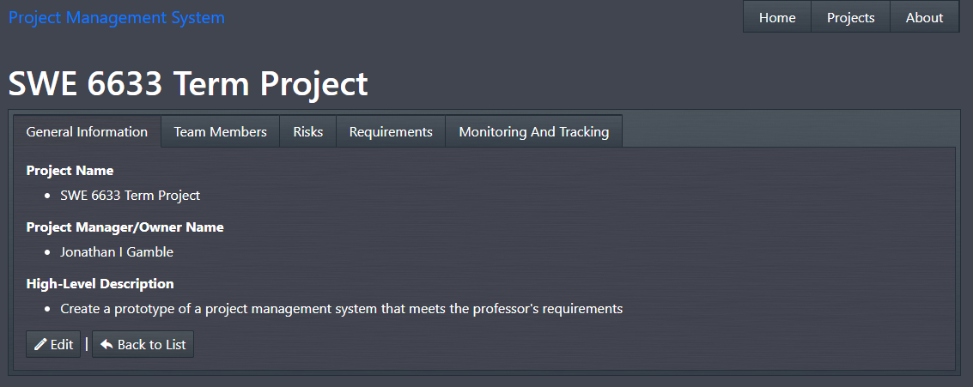

## Delete a Project

To delete a project, the user can choose the Delete option on the Projects Page. The system will navigate the user to a Delete page and ask for confirmation on whether the project should be permanently deleted or not. This Page will provide the user with a read-only view of the all the project’s information excluding the ability to analyze the project’s status. The user will have the option to confirm the deletion of the project via the “Delete Project” button or return to the Projects page view the “Back to List” button in the General Information section. If the project is deleted, the system will navigate the user back to the Projects page which will be updated to reflect the deletion of the project.

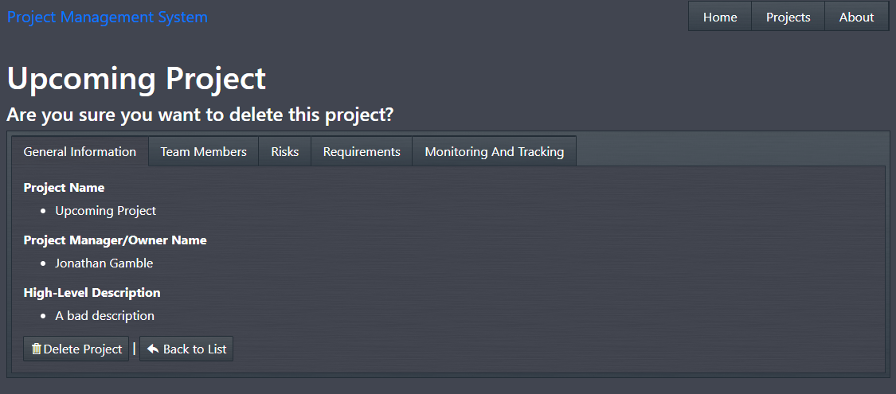

# About Section

For more information on the team that developed the Project Management System, the user can click the About tab at the top of the page. This will navigate them to a page that will give a brief synopsis of each team member.